TASK # 03



Spring 2024
CSE-307L Microprocessor Based System Design Lab

Submitted by: Ali Asghar
Registration No.: 21PWCSE2059
Class Section: C

“On my honor, as student of University of Engineering and Technology, I have neither given nor received unauthorized assistance on this academic work.”

Submitted to:
Dr. Asif Ali Khan

Date:
25th February 2024

Department of Computer Systems Engineering
University of Engineering and Technology, Peshawar

Task:
Write C language code to
- Generate a signal on pin P1.1 having frequency equal to 10 Hz with a duty cycle of 10%.
- When a user presses a button at P1.2 then frequency changes to 20Hz with a 20% duty cycle.
- When a user again presses the same button then frequency changes to 40Hz with a duty cycle of 40%.
- When a user again presses the same button then frequency changes to 80Hz with a duty cycle of 80%.
- Show it on an oscilloscope.
- Each time a user presses a button the signal toggles from case A to B, then B to C, then C to D and finally from D to A, on every subsequent button press.
- Program only in C.
- Use Timers to generate delays.
- Button press means, press and release. Press doesn’t mean you have to keep the button pressed without releasing it.
- Use only Proteus.

Calculations:
$$f_{1}=10Hz$$
$$T_{1}=\frac{1}{f_{1}}=\frac{1}{10}=0.100s=100ms$$
$$On-time=10\% of 100ms=0.010s= 10ms$$
$$Off-time=90\% of 100ms=0.090s=90ms$$

$$f_{2}=20Hz$$
$$T_{2}=\frac{1}{f_{2}}=\frac{1}{20}=0.050s=50ms$$
$$On-time=20\% of 50ms=0.010s=10ms$$
$$Off-time=80\% of 50ms=0.040s=40ms$$

$$f_{3}=40Hz$$
$$T_{3}=\frac{1}{f_{3}}=\frac{1}{40}=0.025s=25ms$$
$$On-time=40\% of 25ms=0.010s=10ms$$
$$Off-time=60\% of 25ms=0.015s=15ms$$

$$f_{4}=80Hz$$
$$T_{4}=\frac{1}{f_{4}}=\frac{1}{80}=0.0125s=12.5ms$$
$$On-time=80\% of 12.5ms=0.010s=10ms$$
$$Off-time=20\% of 12.5ms=0.0025s=2.5ms$$

Code:
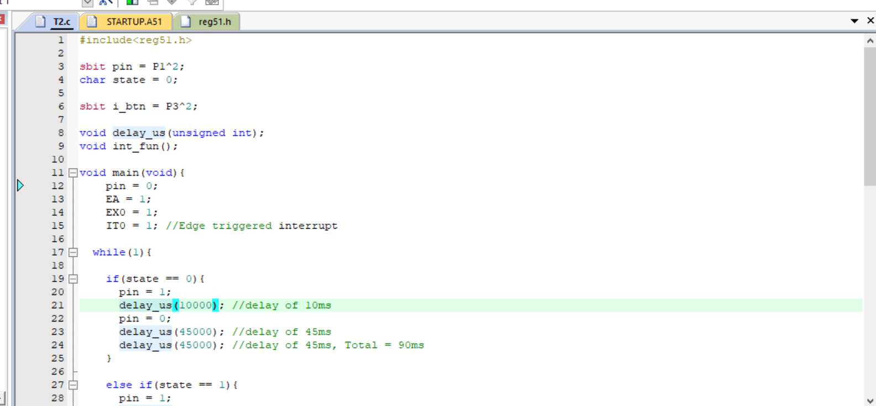
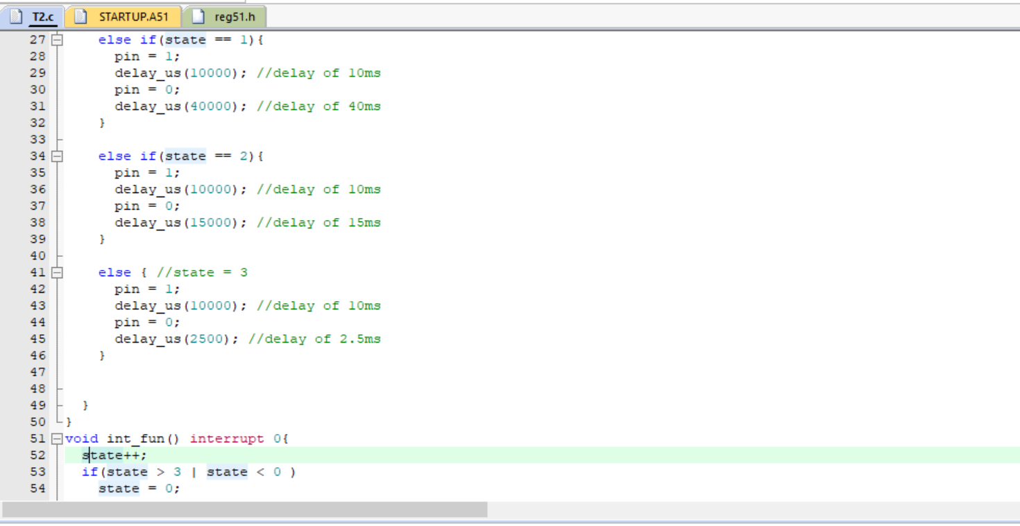
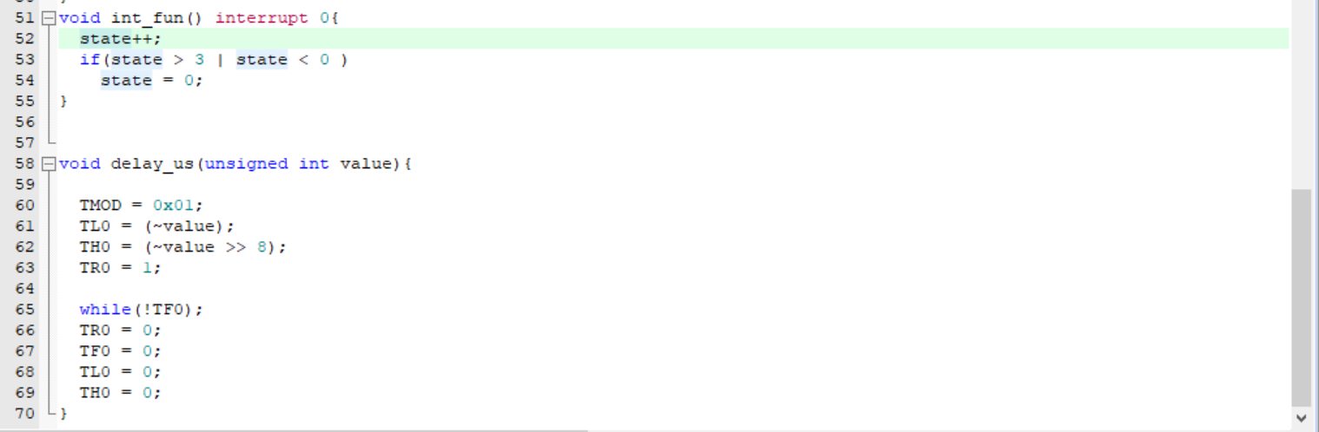

Proteus Simulation:
